Christian Thompson
Module 2.3
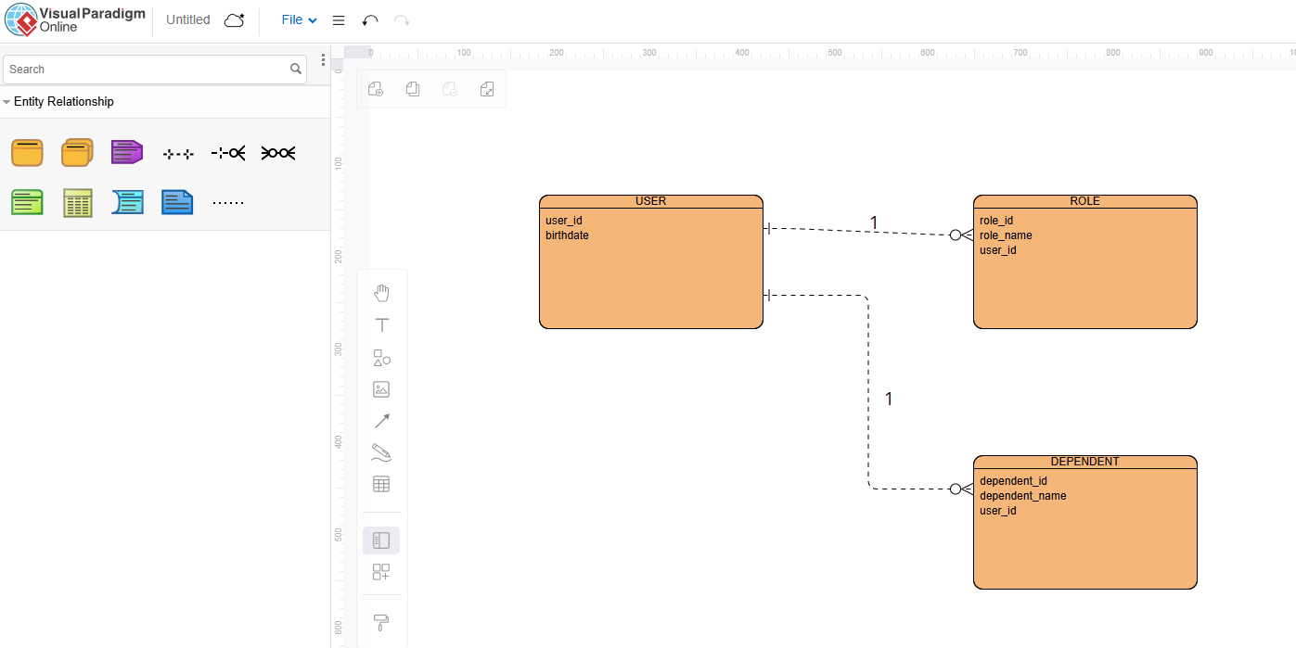

NoSQL Data Structure:
{
“user_id”: 12345,
“birthday”: “06-13-1946”,
“roles”: [
{ “role_id”: 1, “role_name”: “Manager” },
{“role_id”: 2, “role_name”: “Developer” }
],
“dependents”: [
{ “dependent_id”: 1, “dependent_name”: “Jason”},
{ “dependent_id”: 2, “dependent_name”: “Voorhees” }
]
{

